CUVÉE PUECH MOURIÉ 2020

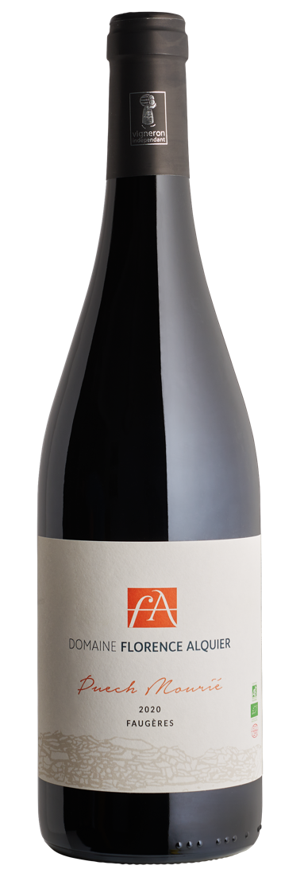
Cuvée : Puech Mourié
AOP : Faugères
Organic red wine

xxx
Grapes (%) : 75% Carignan, 15% Grenache, 7% Syrah, 3% Mourvèdre.
Dark but luminous and purple color. This wine develops notes of Zan, graphite and black fruits.

The attack is fleshy. We then find the freshness of the schists characteristic of Faugères.

Degree of alcohol indicated on the label: 14.5

Average age of the vines: 1985 Yields (hl / ha): 20hl Harvesting method: manual harvest in a box, sorting of the grapes.

Specifics of vinification and aging: carbonic maceration for Carignan, aging in stainless steel vats.

